**Japanese Cemetery in Tashkent**

The Japanese cemetery is located in one of the central parts of Tashkent – Yakkasaray district, inside the cemetery "Fozil-Ota". A resident of Uzbekistan, Mirokil Fozilov, like his father, was the caretaker of this cemetery for 40 long years. The improvement of the cemetery in this family is a common cause, passed down from generation to generation. The merits and valuable contribution of this family did not go unnoticed: Mirokil Fozilov, at the age of 75, was awarded the Imperial Order of the Rising Sun and Silver Rays for protecting the graves of Japanese prisoners of war and maintaining order in the cemetery. On its territory there are 79 graves of Japanese prisoners of war who ended up here after World War II. Prisoners of war built a road for transporting equipment, lived in nearby barracks and came to work every morning in heavy wooden shoes. The knock of a tree on the asphalt during their walk is still remembered in the thoughts of local residents and the cemetery caretaker himself.

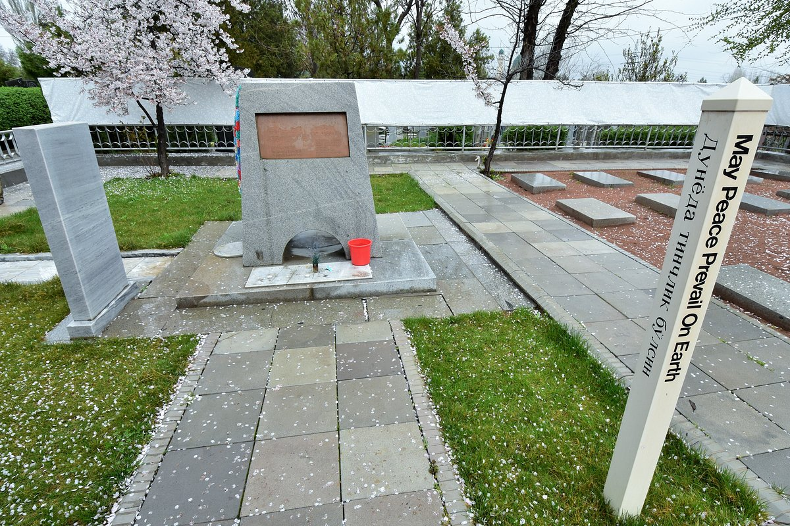

One day, Japanese Ambassador Kyoko Nakayama visited the Japanese cemetery and brought with her a piece of her native land, the national symbol of the Japanese people - a cherry sapling, which Mirokil Fozilov planted next to the graves and began to take care of it. This has been repeatedly noticed not only by the ambassador, but also by all members of the Japanese delegation who come to Uzbekistan and visit the cemetery in tribute to the memory of their fellow citizens. As a reward for the work of his whole life, great gratitude was expressed to Mirokil Fozilov, and the cemetery itself was renamed in his honor.

Today, his sons are taking care of the Fozil-Ota cemetery, and the sakura tree is still blooming and guarding the peace of Japanese prisoners of war. Many religious tourists from Japan come here to worship, read prayers and honor their fellow countrymen, as well as to remember the post-war years and lay beautiful flowers.

