**List of Uzbek theatre groups**

Uzbek Theatre Groups refer to established and new theatre companies in Uzbekistan.

All early theatre in Uzbekistan was in both the Russian and Uzbek languages.

**Theatre Groups in Uzbekistan**

The theatrical life of Uzbekistan is quite different. There are 35 state theaters, including two opera and ballet in Tashkent and Samarkand, 10 music and drama theaters, as well as dolls theaters nationwide. Also, Russian music and drama theaters operate in Tashkent, Samarkand and Ferghana.  
  
Most of the theatres are located in capital city of Uzbekistan. **Here is the list of most leading theatres in Uzbekistan:**  
  
  
**Tashkent**

* Ilkhom Theatre
* Academic Russian Drama Theatre of Uzbekistan
* The State Academic Bolshoi Theatre named after Alisher Navoi
* Uzbek National Academic Drama Theatre
* National Theatre for Young People named Yu Akhunbabayev
* Youth Theatre of Uzbekistan
* Republican puppet theater
* Operetta Theatre (Tashkent State Theater of Musical Comedy)
* Abror Khidoyatov Drama Theatre
* Uzbek Theater of Musical Drama and Comedy Mukimi
* Dance Theatre "Ofarin"

**Samarkand**

* Samarkand Regional Theater of Music and Drama named after Hamid Alimdjan
* Samarkand Russian Theater named after Anton Chekhov
* Regional Puppet Theater named A. Dzhuraeva

**Andijan**

* State Theatre of Drama and Comedy named after Akhunbabayev

**Nukus**

* Karakalpak Music and Drama Theatre named after Stanislavsky
* Karakalpak State Musical Theatre Berdakh

**Fergana**

* Ferghana Regional State Russian Drama Theatre

**The State Academic Bolshoi Theatre named after Alisher Navoi**

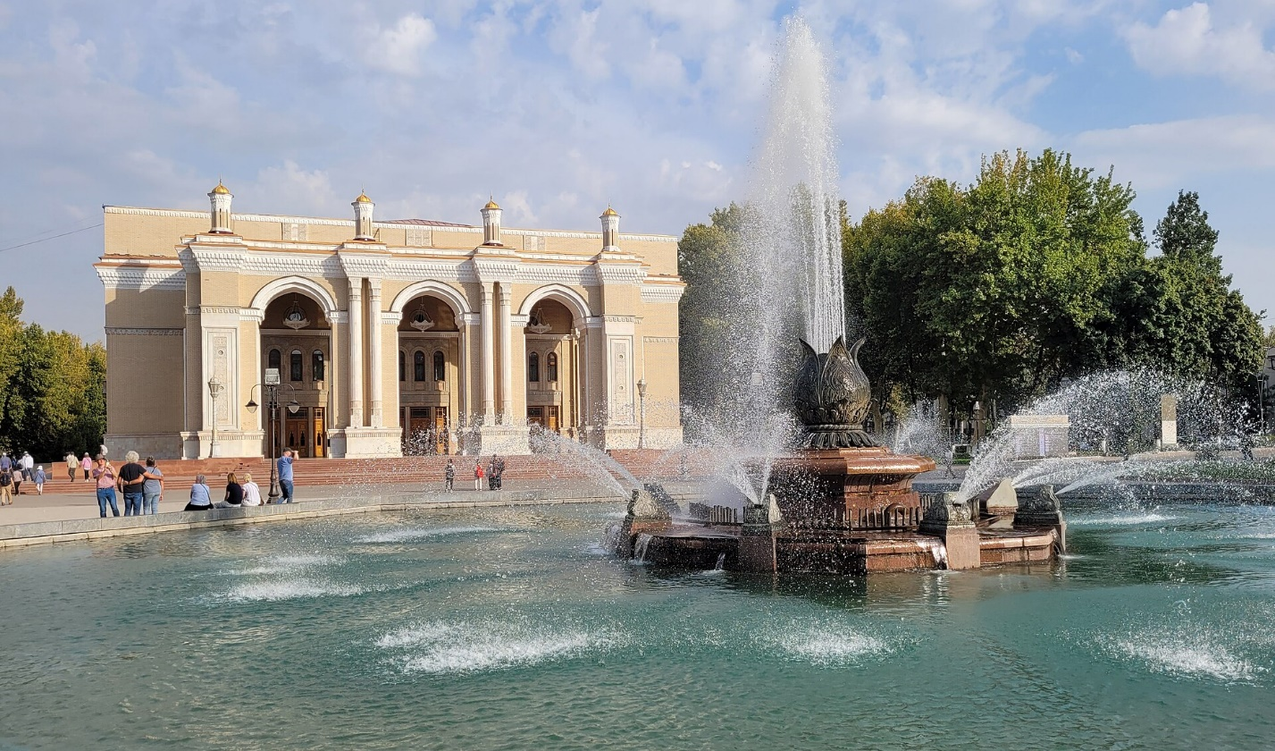

The **Navoi Theater** (Alisher Navoi State Academic Big Theatre) is the national opera theater in Tashkent, Uzbekistan.

It was established in 1929 by amateurs of concert-ethnographic group led by M. Kari-Yakubov and later founded as the professional theatre. In 1939 it was renamed to the Uzbek State Opera and Ballet Theatre. Later, in 1959 the theatre obtained the status of Academic theatre and in 1966 – the status of Bolshoi Theatre.

Designed by Alexey Shchusev, the building of the theater was built in 1942-1947. The Japanese prisoners of war participated in the building construction under forced labor.

The theater has a capacity of 1,400 spectators. The main stage is 540 square meters big.

