

NATIONAL ANTI-DOPING AGENCY OF THE REPUBLIC OF UZBEKISTAN

INFORMATION LETTER

on the international scientific-practical conference

«FIGHT AGAINST THE DOPING: ACHIEVED RESULTS, ETHICAL, LEGAL AND MEDICAL ASPECTS»

(November 6, 2024, Tashkent)

DEAR COLLEAGUES!
We invite you to participate in the international scientific-practical conference on the topic «Fight against the doping: achieved results, ethical, legal and medical aspects» to be held on November 6, 2024 in Tashkent.
At the conference, it is planned to organize various discussions and presentations on the progress made in anti-doping in Uzbekistan in recent years, the work that needs to be done, and other topical issues related to doping. It is expected to hold a wide range of thematic presentations on the issues of legal regulation of the anti-doping, development of national anti-doping rules, improvement of legal standards related to the field, as well as the use of prohibited substances in sports as a therapeutic use exception.
Working languages ​​of the conference: Uzbek, Russian, English.
Main topics of the conference:

1. Legal regulation of the anti-doping
2. Analysis of the experience of anti-doping legislation of foreign countries.
3. Development of proposals for regulating the field in the Republic of Uzbekistan
4. Therapeutic use exceptions

Participants: specialists in the field of sports law, as well as experts in the field of legislation, anti-doping service, physical education and sports.

CONFERENCE FORM
- direct participation (participation with a lecture or participation);
- online participation (participation with a lecture or participation (participation through the ZOOM platform).

TERMS AND CONDITIONS OF PARTICIPATION IN THE CONFERENCE

Participation in the conference is free. Travel, accommodation and meals are covered by the participants or the sending organization.
Those who expressed their desire to participate in the conference
1. Send the application form (Appendix 1) for participation in the conference to the e-mail of the organizing committee info@uznda.uz by October 1, 2024;
2. Confirm the compliance of the presented report with the topic of the conference.

Electronic form of the conference program

1. It will be posted on the official website of the National Anti-Doping Agency of the Republic of Uzbekistan no later than September 20, 2024.
2. The collection of conference materials will be posted on the official website of the National Anti-Doping Agency of the Republic of Uzbekistan no later than December 1, 2024.

Address of the organizing committee: National Anti-Doping Agency of the Republic of Uzbekistan: Republic of Uzbekistan, Tashkent city, Yunusabad district, A.Kadiri street 2.
Phone number for contact: (+99895) 199-55-01;

Our pages on social networks:

Telegram: Instagram: Facebook:
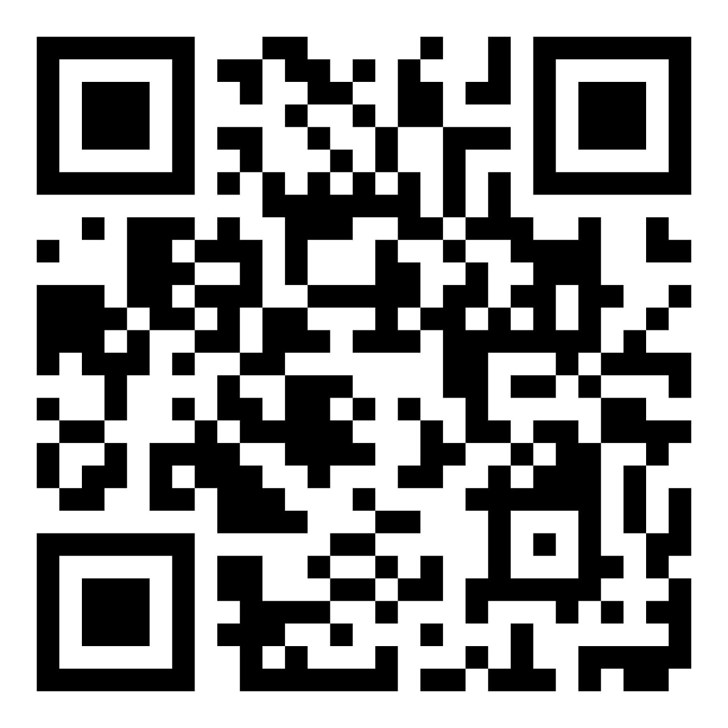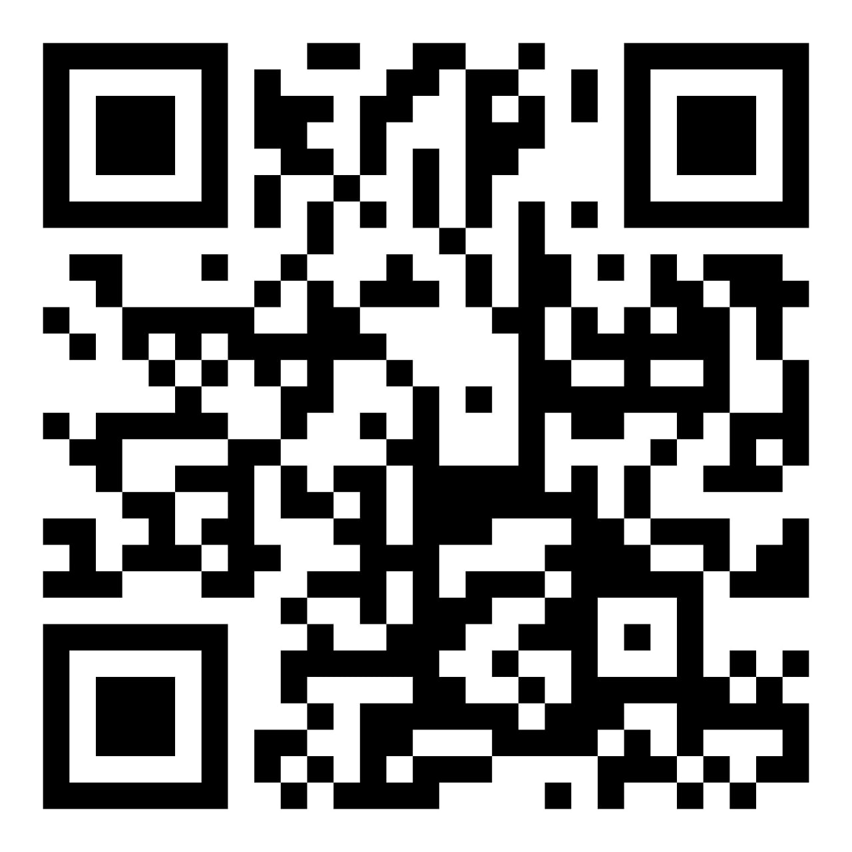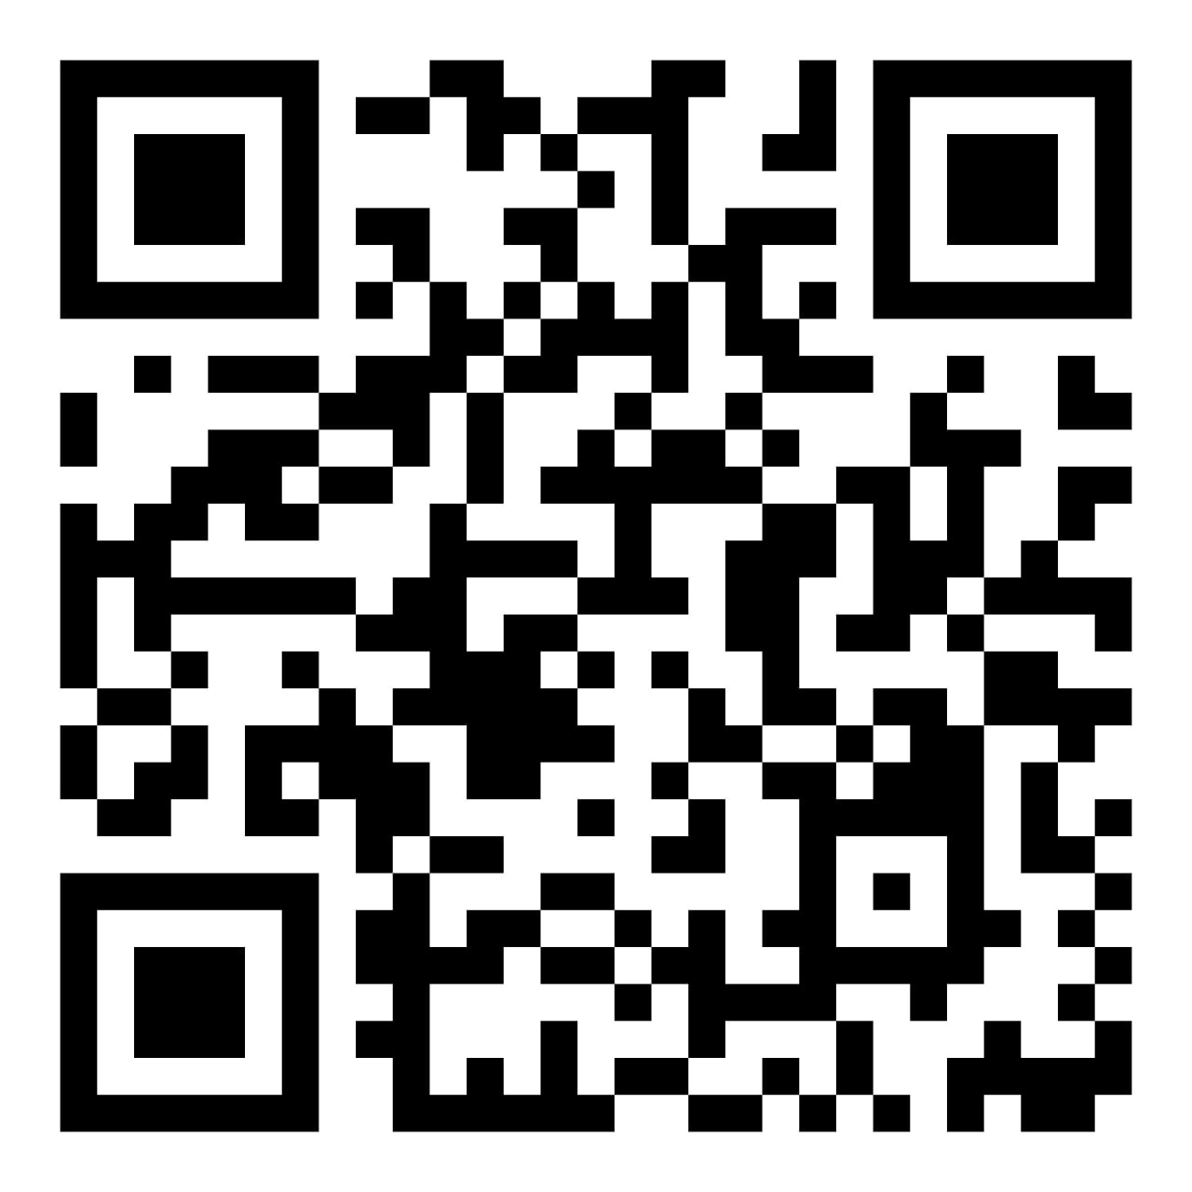

WE WILL BE HAPPY TO HAVE YOUR PARTICIPATION IN OUR CONFERENCE!

Sincerely,
Organizing Committee of the Conference

Appendix 1

APPLICATION

«Fight against the doping: achieved results, ethical, legal and medical aspects»

Thematic orientation of the conference
Name of the presentation
Information about the author:
Author's name
Scientific title
Academic degree
Position (indicating department, etc. without abbreviation)
Organization (full name without abbreviation)
Form of participation in the conference: with/without presentation
Information about the co-author(s) (if any):
Author's name
Scientific title
Academic degree
Position (indicating department, etc. without abbreviation)
Organization (full name without abbreviation)
Form of participation in the conference: with/without presentation
Contact information for communication
Phone:
E-mail:

